**Worksheet-3.1**

**Student Name:- Pushpraj Roy UID:- 20BCS9866**

**Branch:- BE- CSE Section/Group:- WM_617 “A”**

**Subjetct Code:- 20CSP-321 Semester:- 5th**

**Subject Name:- PBLJ Lab**

1. **Aim/ Overview of the practical:-**

Create a palindrome creator application for making a longest possible palindrome out of given input string.

1. **Task To be done :-**

Write the program to create an application to form a largest palindrome from given String.

1. **S/W Requirements:-**

* JDK
* VS Code

1. **Code :-**

package unit2;

import java.util.HashMap;

import java.util.Map;

import java.util.Scanner;

public class WorkSheet8 {

public static String longestPalindrome(String str) {

if (str == null || str.length() == 0) {

return str;

}

Map<Character, Integer> freq = new HashMap<>();

for (char ch: str.toCharArray()) {

freq.put(ch, freq.getOrDefault(ch, 0) + 1);

}

String mid_char = "";

StringBuilder left = new StringBuilder();

for (var entry: freq.entrySet()){

char ch = entry.getKey();

int count = entry.getValue();

if (count % 2 == 1) {

mid_char = String.valueOf(ch);

}

left.append(String.valueOf(ch).repeat(count / 2));

}

StringBuilder right = new StringBuilder(left).reverse();

return ("" + left + mid_char + right);

}

public static void main(String args[]) {

Scanner in = new Scanner(System.in);

System.out.println("Enter your String: ");

String str = in.next();

System.out.println("The longest palindrome is " + longestPalindrome(str));

in.close();

}

}

1. **Observations/Discussions/ Complexity Analysis:**

Here we have created the palindrome function to performed an operation on a String to create a largest possible palindrome.

1. **Result/Output/Writing Summary:-**

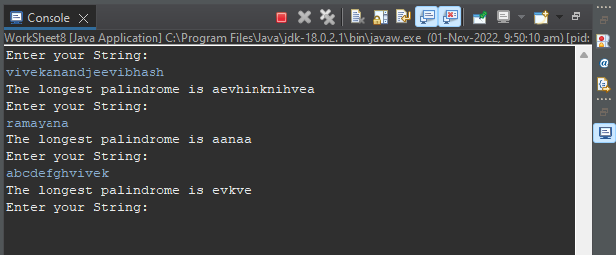

1. **Learning outcomes (What I have learnt):**

* Learnt the concept of palindrome.
* Learnt the concept of StringBuilder ().
* Learnt the concept of HashMap ().
* Learnt the concept of StringBuilder Manipulation such as Reverse.
* Successfully executed the code and completed the Worksheet.